**SENDING CORRESPONDENCE**

1.**What is Correspondence?**

Organizations depend on timely communication to establish a shared understanding of transactions or assignments. In Pega Platform, the system can send automated email correspondence to all relevant parties.

Correspondence is an outgoing email, letter, fax or text message that is produced by system and its users. It is also useful for sending notifications to one or more of the work parties in a case.

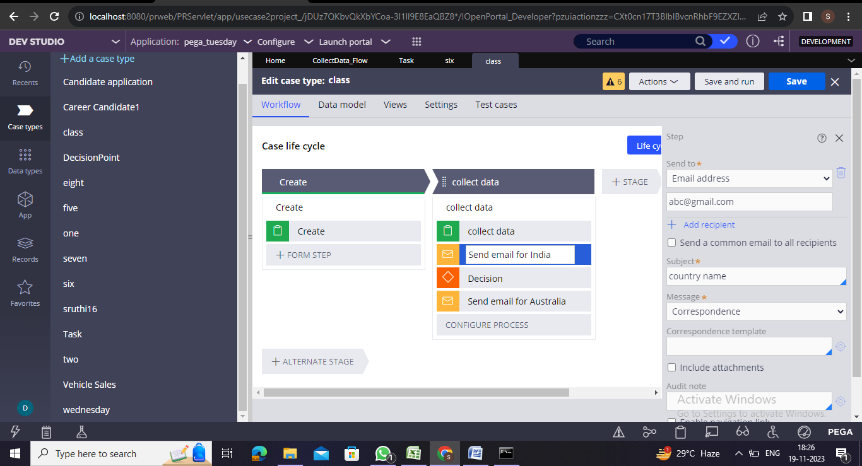

**2.What are the different types of Correspondence?**

Pega provides four correspondence types to send automated:

1. Email
2. SMS phone text
3. Fax
4. Printed letter

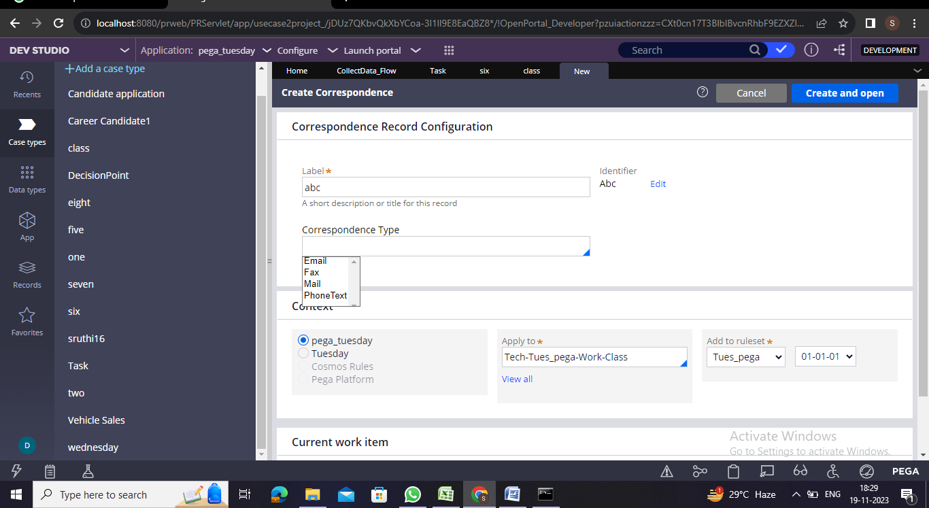

**3.With whom do I need to communicate?**

Identify users with whom to communicate - One option is to send correspondence to a specific email address. This option depends on a consistent email address.

To avoid recurring changes to an email address, you can use fields, user references, and participants to send email correspondence.

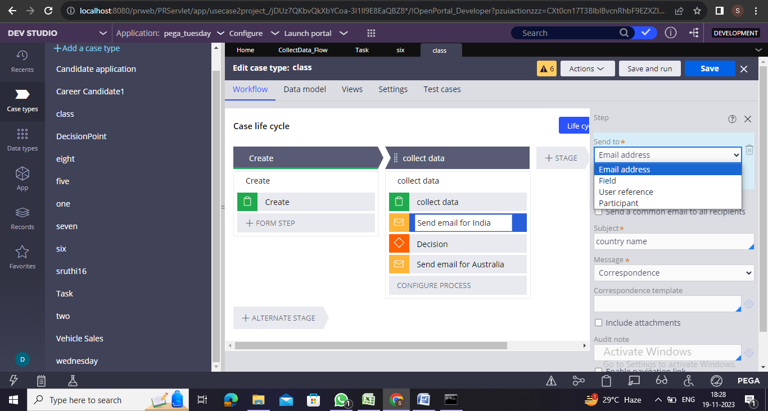

**Fields :**

* On left side of the case life cycle design we have Fields and Customer Email.
* You can send an email based on the value of a field.

**Example:** For example, a new customer signs up for an account. The customer enters an email address in the Customer email field. When the

customer submits information, Pega Platform uses the value entered in the field by the customer to send a confirmation email.

**User Reference :**

* In cases where correspondence needs to be sent to one specific user or Appropriate user in an application.
* Create Operator and Update Operator are automatically defined in data model for each data type associated with the case type.

**Example:** In an Bank Loan Application,the user has to request the Manager(Specific User)for approval of a Loan.

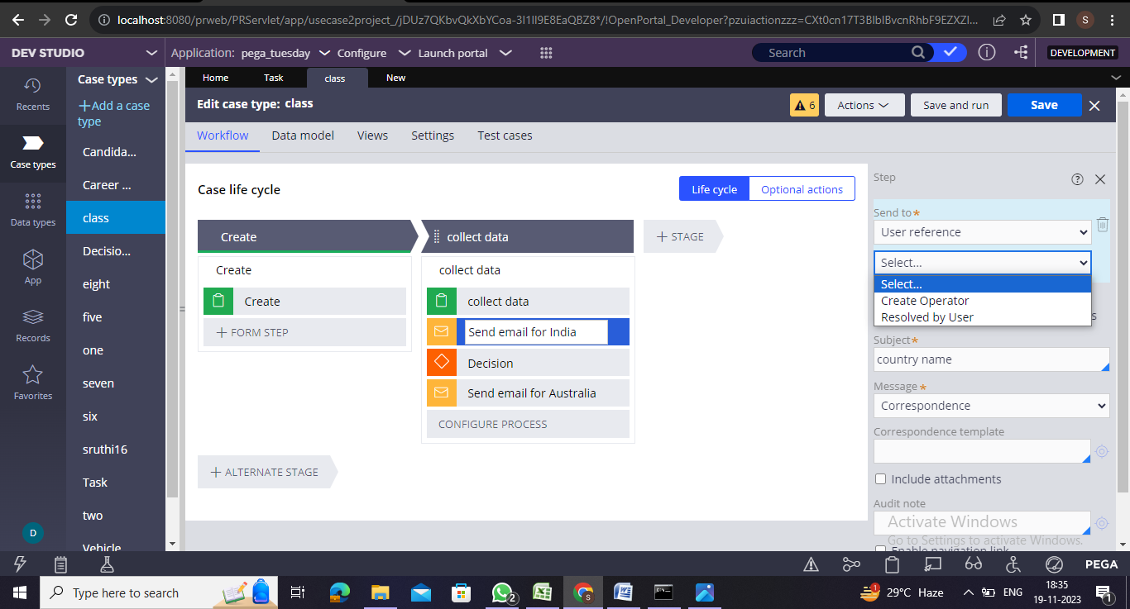

**Participant :**

* Pega Platform can also use participant information to send correspondence to a group of stakeholders.
* In Participants we have different fields like Customer,Owner,Interested and All Participants.

Customer - The person on whose behalf the case is transacted. This person may not process the case but may want — or need — notification of any changes.

Owner - The person who created the case.

Interested - A person who tracks the progress of a case but does not process the case.

All participants – Email Correspondence sent to all participants.

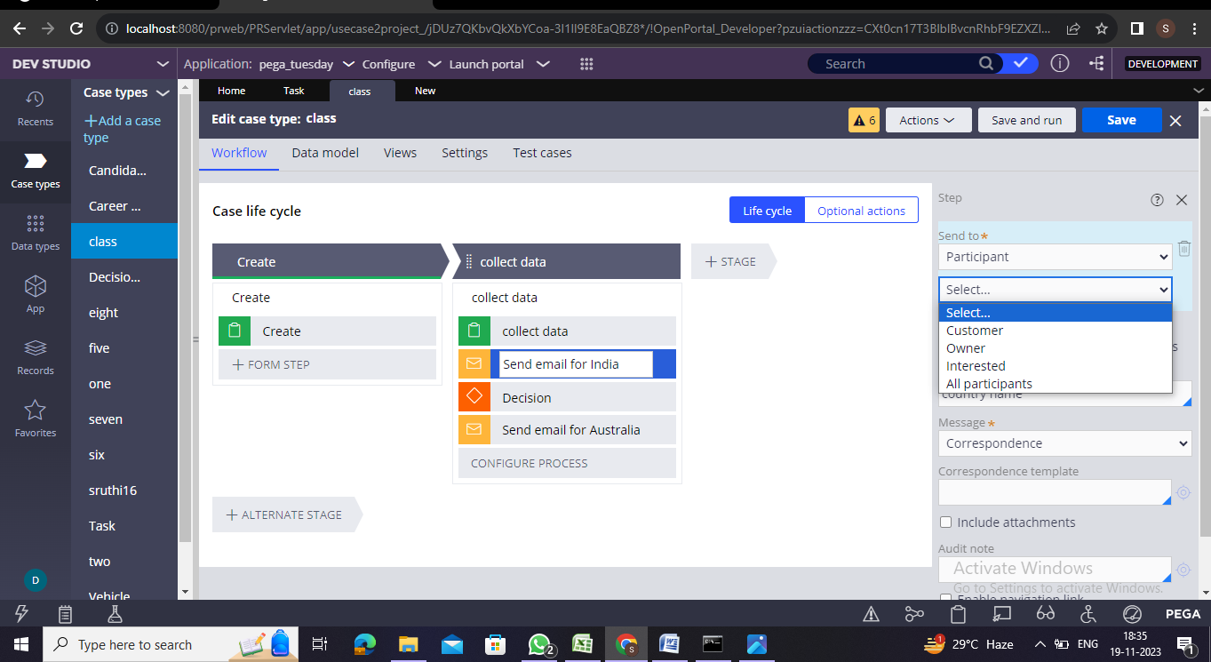

**4.How will the communication be composed?**

Pega Platform provides a rich text editor to create formatted email correspondence. The editor allows you to reuse data from the case in the email. You can also use existing correspondence templates. Pega Platform provides out-of-the-box templates that use case processing data, such as the case ID (*.pyID*) and case status (*.pyStatusWork*).

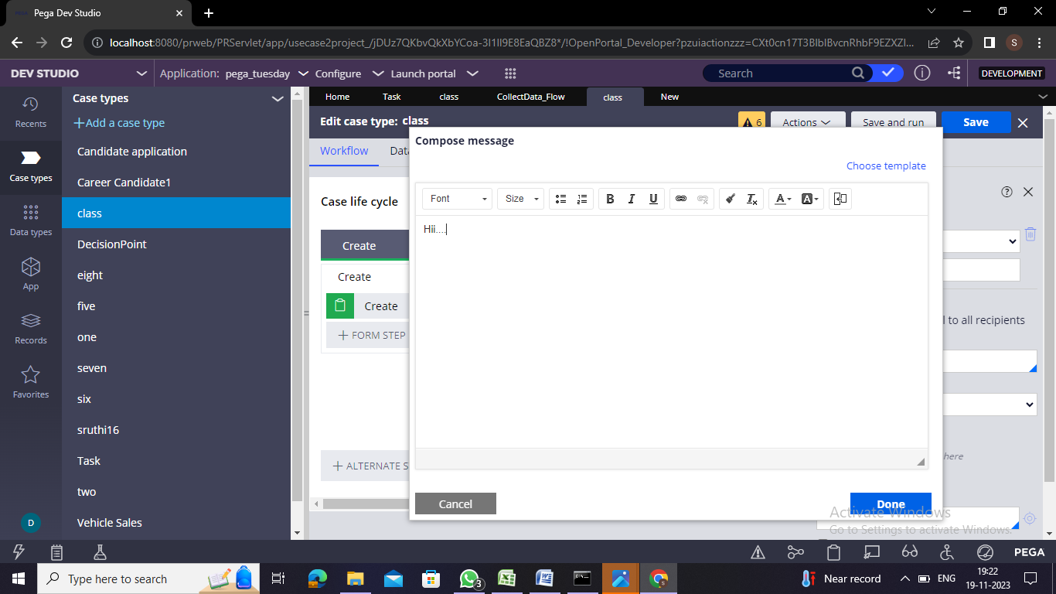

**Example** **:** you can enter a greeting with the customer's first and last name by referencing the fields that capture this information in the case.

5.**When does the communication need to be sent?**

Here we have to add a Send email automation to your case to send an email. When a case reaches the Send email step, the email is automatically sent to the selected parties.

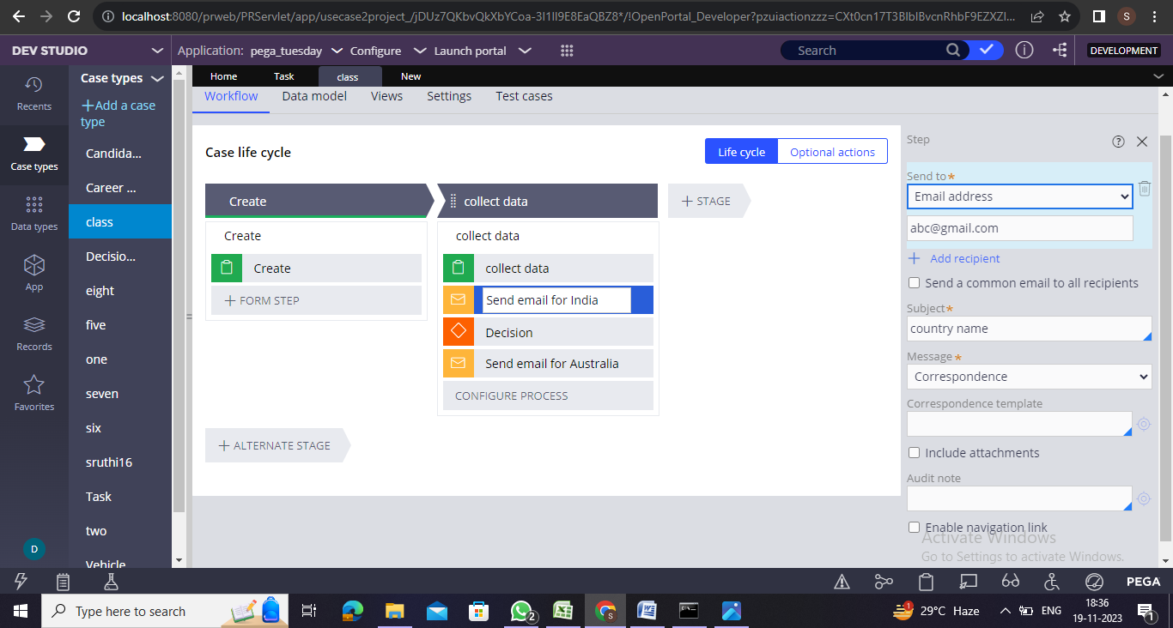

**Example :** In a Place order process, users select order items, the shipping address, and the payment method. Once users confirm the order, the case automatically sends users a confirmation email.

6.**How can you configure Correspondence?**

In App or Dev Studio:

1. Click +Step > More > Automation.

2. Select the Send Email step.

3. Configure the step by selecting the Send to option.

4. Enter a subject for the email.

5. Select an existing message or click Compose to create a new message.

**7.What is Correspondence Rule?**

A Correspondence Rule is a type of rule in Pega Infinity that defines the content and format of outgoing emails, letters, faxes, or text messages that are produced by the system or its users. Correspondence is typically associated with one work item, and can include text and images. Correspondence that is sent to the originator of a work item is known as an acknowledgment.

* A correspondence rule is an instance of class Rule-Obj-Corr.
* Correspondence can be created under Process Category.

**8.How can you configure Correspondence Rule?**

In Dev Studio

1. Select App explorer

2. Expand the class/case type

3. Expand process

4. Right-click and select Create

5. Enter a name in the Label field

6. Select the correspondence type from the autocomplete field.

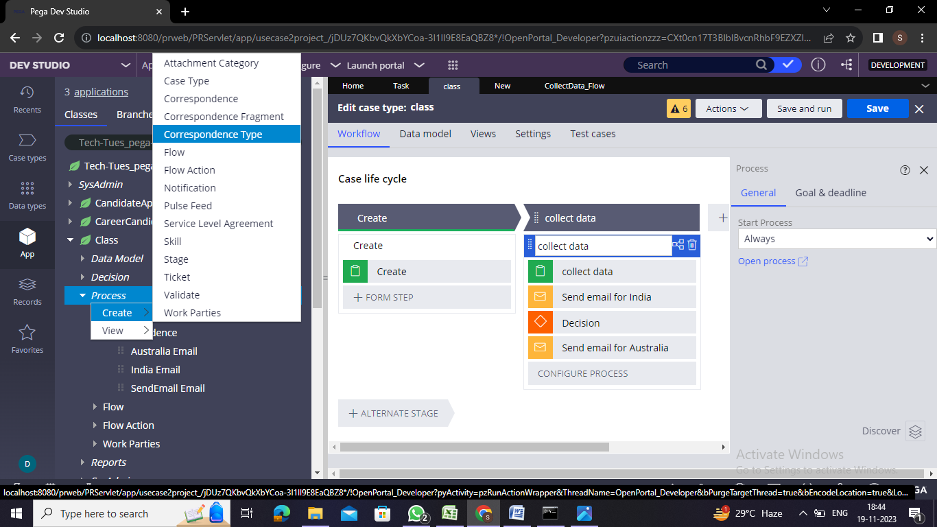

**9.What is Case Level Notification?**

Case-level notifications automatically send notifications to the user who is associated with the worklist.

**10.How to configure Case Level Notification?**

1.On the **Settings Tab** in the case type.

2.In the **Notifications**section, select the **Email user when the assignment is routed to worklist**checkbox.

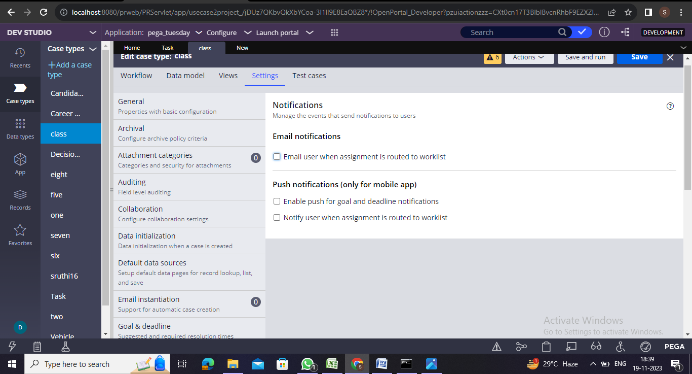

**11.What is Utility Shape?**

A utility shape is a type of shape that can be used in a flow rule to perform a specific task, such as displaying a message or performing a calculation. Utility shapes are typically used to perform tasks that are not directly related to the main flow of the process, but are still necessary for the process to function correctly.

Examples of utility shapes include the Wait shape, which pauses the flow for a specified amount of time, and the Utility shape, which can be used to perform a variety of tasks, such as updating a property or sending an email.

**12.How can you configure Utility shape?**

1. Select the case type.

2. Open the process diagram.

3. Right-click and add the utility shape.

4. Double-click the shape.

5. Edit the utility properties.

6. Enter CorrNew in the Rule field.

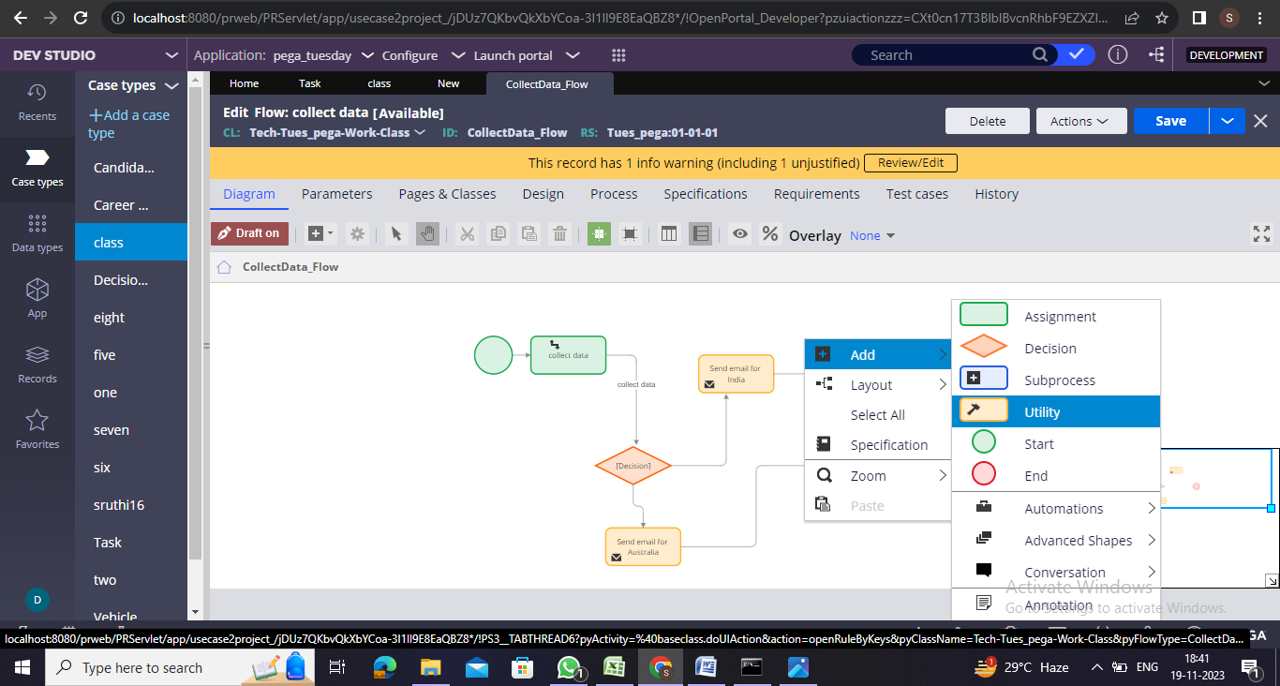 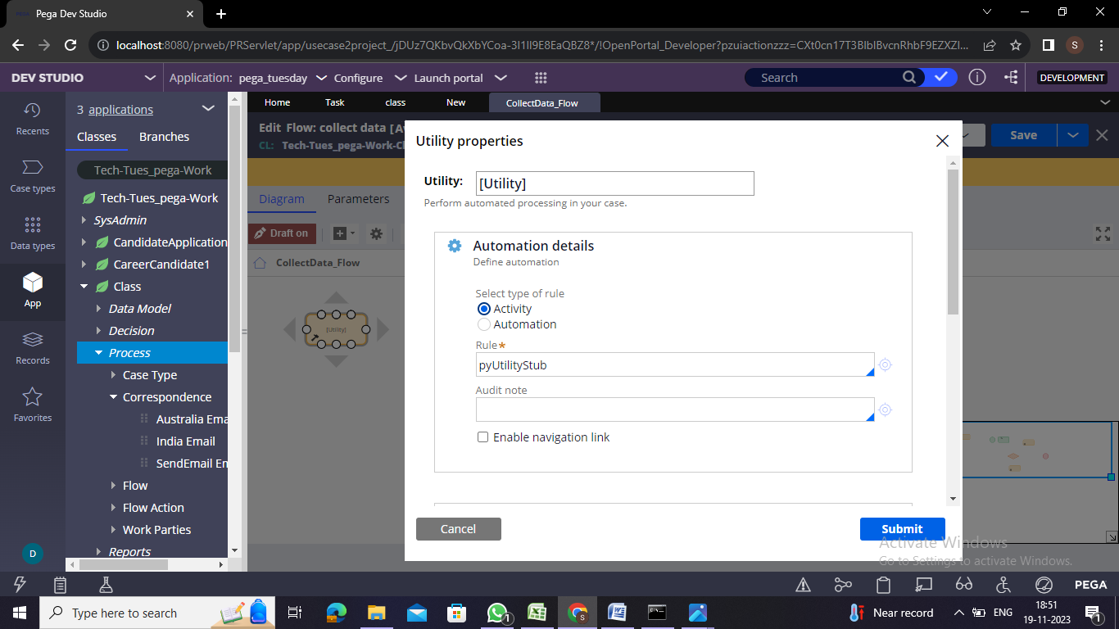

**13.What is the difference between activity and utility?**

An activity contains a sequence of steps that perform in the instructed order. Activity is a rule of Rule-Obj-Activity, and Utility is a shape in the Pega flow. This shape refers to an activity with the usage type which is selected as a Utility.

**14.Why is Utility Shape is more effective than Send Email Step?**

A Utility shape is more effective than Send Email Step because it offers greater flexibility than the Send Email step, by configuring with the CorrNew activity rule.

**15.Can correspondence rules be integrated with external systems or third-party email services?**

Yes, correspondence rules in Pega can be integrated with external systems or third-party email services to send emails or other types of correspondence by SOAP or REST Integration, Email Channel Integration, Third-Party Email Service Provider.

**16.Can I send correspondence based on business rules?**

A: Yes, Pega allows you to send correspondence based on business rules. You can configure decision logic in your application that determines when and how correspondence should be sent, ensuring that it aligns with your business requirements.

**17.How can I include dynamic data in correspondence?**

A: Pega allows you to include dynamic data in correspondence using placeholders or tokens. These placeholders are replaced with actual data at runtime, ensuring that the correspondence is personalized and relevant to each recipient.

**18. Can I track the status of sent correspondence?**

A: Yes, Pega provides tools for tracking the status of sent correspondence. You can monitor the delivery status, whether it was successfully sent, and track any errors or issues that occurred during the process.

**19. How do I configure a flow to send correspondence?**

A: To configure a flow to send correspondence, you can use the "SendCorr" smart shape. This shape is placed in the flow, and you configure it by specifying the correspondence rule, recipient, and other relevant details.

**20. Can I automate the scheduling of correspondence?**

A: Yes, Pega supports the automation of correspondence scheduling. You can use agents or job schedulers to automatically trigger the generation and sending of correspondence based on predefined schedules or events.

**21. How can I troubleshoot issues with sending correspondence?**

A: Pega provides robust logging and monitoring capabilities. You can check the logs and monitoring tools to identify and troubleshoot any issues with sending correspondence. Additionally, Pega provides error handling mechanisms within flows to manage exceptions during the correspondence process.

**22.Can I include attachments in email correspondence?**

A: Yes, Pega allows you to include attachments in email correspondence, providing a way to send documents or additional information along with the email.

**23. How do I handle HTML formatting in email correspondence?**

A: Email Correspondence rules in Pega support HTML formatting, allowing you to create visually appealing and formatted content in the body of the email.

**24. How can I include dynamic data in correspondence?**

A: Dynamic data can be included in correspondence by using placeholders or tokens, which are replaced with actual data at runtime.

**25. Can I customize correspondence based on user preferences?**

A: Yes, Pega allows you to customize correspondence based on user preferences by incorporating decision logic in your application.

**26. What is a data transform, and how is it related to dynamic data in correspondence?**

A: A data transform in Pega is a rule that transforms data from one format to another. It can be used to prepare dynamic data for inclusion in correspondence.

**27. Are there predefined tokens for common data in Pega correspondence?**

A: Yes, Pega provides predefined tokens for common data, such as the current date, user name, or case details, which can be easily included in correspondence.

**28.How can I test and preview correspondence with dynamic data?**

A: Pega provides tools to test and preview correspondence, allowing you to see how dynamic data will be populated before sending the actual communication.